Assignment 2
1. Inline Functions
Write a C++ program to create an inline function that calculates the square of a number. Accept the number from the user and display the square.
#include <iostream>
using namespace std;

// Defined as an inline function
inline int Square(int num) {
return num * num;
}

int main() {
int n;

cout << "Enter the Number: ";
cin >> n;
int result = Square(n);

cout << "\n\t The square of " << n << " is: " << result << endl;

return 0;
}

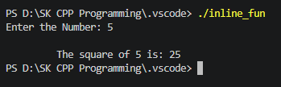
2. Recursive Function
Write a C++ program to find the factorial of a given number using a recursive function.
#include <iostream>
using namespace std;
int fact(int n){
if(n==1)
{
return 1;
}
else
{
return n*fact(n-1);
}
}
int main()
{
int num;
cout<<"Enter the Number";
cin>>num;
cout<<"\n The factorial of "<<num<<" is"<<fact(num)<<endl;
return 0;
}
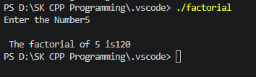
3. Recursive Function
Write a C++ program to print the first N Fibonacci numbers using recursion.
#include <iostream>
using namespace std;
int fibo(int n){
if(n<=0)return 0;
if(n==1)return 1;
return fibo (n-1)+ fibo (n-2);

}
int main()
{
int n;
cout<<"Enter the Number of fibonsncci:";
cin>>n;
cout<<"\n he first "<< n <<"fibonsncci num are:";
for ( int i=0; i<n; i++){
cout <<fibo(i)<<" ";
}
cout<<endl;
return 0;
}

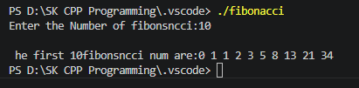
4.Recursive Function
Write a C++ program to calculate the sum of digits of a given number using recursion.
#include <iostream>
using namespace std;
int sumDigit ( int num)
{
if (num==0)
return 0;
return (num%10)+sumDigit(num/10);
}

int main()
{
int number;
cout<<"Enter the Number integer:";
cin>>number;
cout<<"\n sum of Digit is :"<< sumDigit(number) <<endl;
return 0;

}

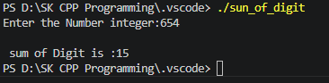
5. Function Overloading
Write a C++ program to overload a function named area() to calculate the area of:
void Area(int red) ; //to calculate area of circle
void Area(int length,int Breadth) ; //to calculate area of rectangle.

#include <iostream>
using namespace std;

void Area(int red) {
cout<<3.14 * red * red;
}

void Area(int length, int breadth) {
cout<<length * breadth;
}

int main() {
// 1. Circle Area
int radius;
cout << "Enter radius of the circle: ";
cin >> radius;
cout << "Area of Circle is: " << Area(radius) << endl << endl;

// 2. Rectangle Area
int length, breadth;
cout << "Enter length of the rectangle: ";
cin >> length;
cout << "Enter breadth of the rectangle: ";
cin >> breadth;
cout << "Area of Rectangle is: " << Area(length, breadth) << endl;

return 0;
}

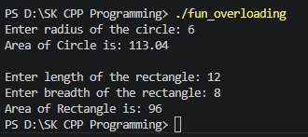
6. Function Overloading
Write overloaded functions named maximum() to find the largest among:
Two integers
Three integers
Two floating-point numbers
#include <iostream>
using namespace std;

int maximum( int a, int b)
{
if (a>b){
return a;
}
else {
return b;
}
}

int maximum( int a, int b, int c)
{
if (a>b && a>c){
return a;
}
else if(b>a && b>c){
return b;
}
else{
return c;
}

}
float maximum( float a, float b)
{
if (a>b){
return a;
}
else {
return b;
}
}

int main() {
// 1. Two integers
int a, b;
cout << "Enter the number a and b";
cin >> a;
cin >> b;
cout << "maximum number is: " <<maximum( a, b) << endl << endl;

// 2. Three integers
int p,q,r;
cout << "Enter the number p,q,r:";
cin >> p;
cin >> q;
cin >> r;
cout << "maximum number is: " <<maximum(p,q,r) << endl;

float num1, num2;
cout << "Enter the number num1 and num2";
cin >> num1;
cin >> num2;
cout << "maximum number is: " <<maximum(num1, num2) << endl << endl;

return 0;
}

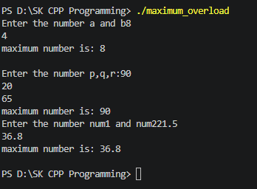
7. Pass by Reference
Accept two numbers from user pass these numbers to Swap function, Function should interchange the values
#include <iostream>
using namespace std;

int swap( int a, int b)
{
int temp;
temp=a;
a=b;
b=temp;
cout<<"After swap value of a :"<<a<<endl;
cout<<"After swap value of b :"<<b<<endl;

}

int main() {
// 1. Two integers
int a, b;
cout << "Enter the number a :";
cin >> a;
cout << "Enter the number a :";
cin >> b;
cout<<swap( a, b) << endl << endl;
return 0;

}

8. Default Function Arguments
Write a C++ program to calculate simple interest using a function with default arguments.
Use the default rate of interest as 8%.
calculateSI(principal, years)
calculateSI(principal, years, rate)
#include <iostream>
using namespace std;
void SI(float principal, float years, float rate=8.0){
float interest = (principal * rate * years) / 100.0;
cout << "Simple Interest: " << interest << endl;
}

int main ()
{
cout << "Calculating with Default Rate (8%)" << endl;
SI(50000,2.5);

cout << "\nCalculating with Explicit Rate (9.6%) " << endl;
SI(25000,4,9.6);
return 0;
}
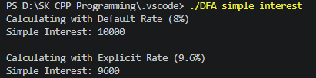
9. variable parameter
Write a C++ program using a variable parameter list to calculate the sum of any number of integers.
sum(3,10,20,30)
sum(5,2,4,6,8,10)
#include <iostream>
#include <cstdarg>
using namespace std;
int sum(int count, ...)
{
//Declare
va_list args;
//init
va_start(args, count);
int total=0;
for (int i=0; i <count; i++){
total+=va_arg(args, int);
}
va_end(args);
return total;
}

int main(){
cout<<"Sum="<<sum(3,10,20,30)<<endl;
cout<<"Sum="<<sum(5,2,4,6,8,10)<<endl;
return 0;
}

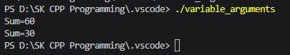
------------ Classes and Objects -----------------
1. Implement Date class with following
Data members
day,month,year
Member functions
accept function
display function
overload display function. pass character value which is separator for day,month and year
CheckLeapYear function
#include <iostream>
using namespace std;
class Date{
private:
int day, month, year;
public:
void accept(){
cout<<" enter the day , month ,year ";
cin>> day >> month >>year;

}
void Display(){
cout<<"\n\t Date:"<<day<<"/"<<month<<"/"<<year;
}
void SetDay (int d){
day =d;
}
void SetDate(int d, int m, int y){
day=d;
month=m;
year=y;
}
void leap_year(){
if ((year % 400 == 0) || (year % 4 == 0 && year % 100 != 0)){
cout <<"\n"<<year<< " is leap lear";
}
else{
cout <<"\n"<<year<< " not leap lear";
}
}
};

int main(){
Date d1;
d1.accept();
d1.Display();
d1.leap_year();
return 0;
}

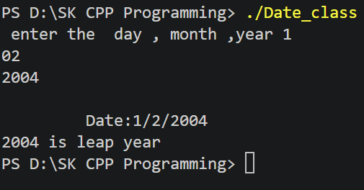
2. Implement Complex class with following
Data members
real,img
Member function
accept function
display function
AddComplexNumbers
#include <iostream>
using namespace std;

class Complex {
private:
int real;
int img;

public:
void accept() {
cout << "\n\tEnter the real part: ";
cin >> real;
cout << "\tEnter the imaginary part: ";
cin >> img;
}

void display() {
if (img >= 0) {
cout << real << " + " << img << "i" << endl;
} else {
cout << real << " - " << -img << "i" << endl;
}
}

Complex AddComplexNumbers(Complex c) {
Complex temp;
temp.real = real + c.real;
temp.img = img + c.img;
return temp;
}
};

int main() {
Complex c1, c2, c3;

cout << "Enter First Complex Number " << endl;
c1.accept();

cout << "\n Enter Second Complex Number" << endl;
c2.accept();

cout << "\nFirst Complex Number: ";
c1.display();

cout << "Second Complex Number: ";
c2.display();

c3 = c1.AddComplexNumbers(c2);

cout << "\nResult of Addition: ";
c3.display();

return 0;
}

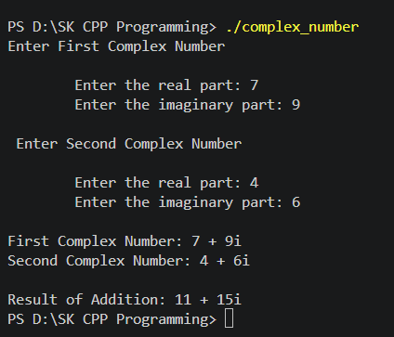
3. Library Management
Create a LibraryBook class containing:
Book ID
Book Name
Author Name
Price
Implement:
Accept function
Display function
give 10% discount to very book
#include <iostream>
#include <string>
using namespace std;

class LibraryBook {
private:
int bookID;
string bookName;
string authorName;
double price;

public:
// Function to accept book details
void accept() {
cout << "Enter Book ID: ";
cin >> bookID;
cin.ignore();
cout << "Enter Book Name: ";
getline(cin, bookName);
cout << "Enter Author Name: ";
getline(cin, authorName);
cout << "Enter Price: ";
cin >> price;
}

// Function to calculate and apply 10% discount
void giveDiscount() {
double discount = price * 0.10;
price = price - discount;
}

// Function to display book details
void display() {
cout << "\nBook ID: " << bookID << endl;
cout << "Book Name: " << bookName << endl;
cout << "Author Name: " << authorName << endl;
cout << "Price (After 10% Discount): " << price << endl;
}
};

int main() {
LibraryBook book;

cout << " Enter Book Details " << endl;
book.accept();

// Apply the requested 10% discount
book.giveDiscount();

cout << "\nDisplaying Book Records";
book.display();

return 0;
}

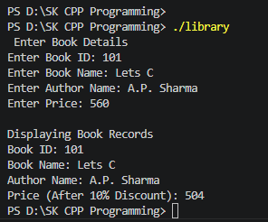
4.Create box class
Data members
length, width, height;
Implement:
Accept function
Display function
Calculate volume() function
#include <iostream>
using namespace std;
class Box{
private:
int length, width, height;
public:
void accept(){
cout<<" enter the length, width, height ";
cin>> length>> width>> height;

}
void Display(){
cout<<"\n\t Length is:"<<length;
cout<<"\n\t width is:"<<width;
cout<<"\n\t height is:"<<height;
}
void Calculate_volume(){
cout<<"\n The volume of box is:"<<(length* width* height);

}
};

int main(){
Box b1;
b1.accept();
b1.Display();
b1.Calculate_volume();
return 0;
}

